SITE PICTURES
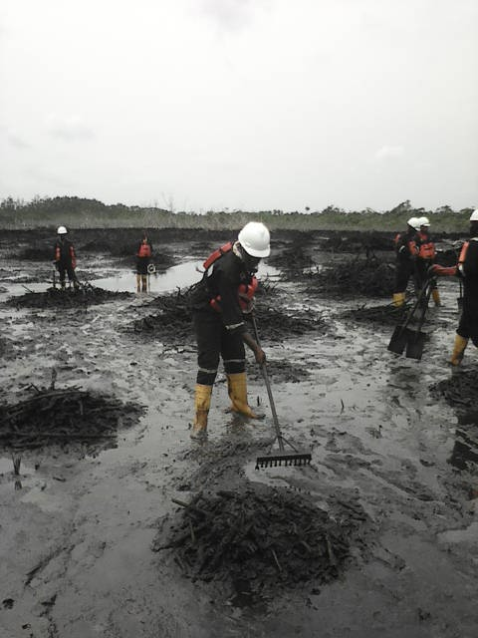
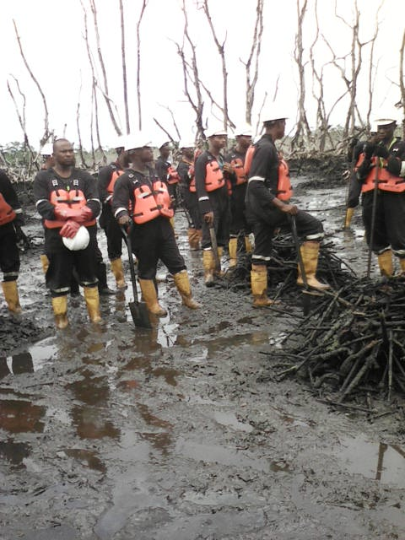
Figure1 clearing and cutting of dead mangrove.
Figure 1 Work ongoing at the clean up site
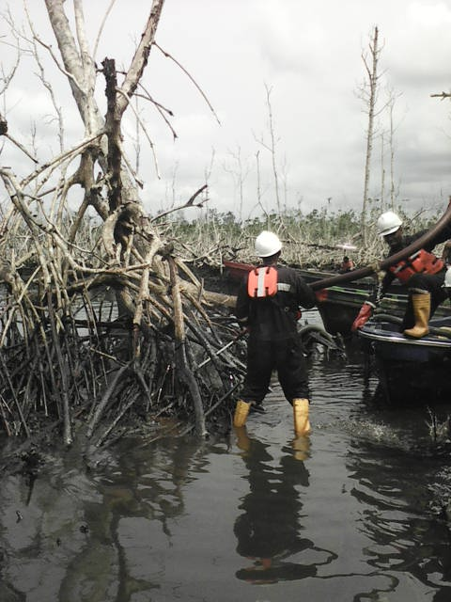
Figure 2 STILL FLUSHING PROCESS ONGOING.
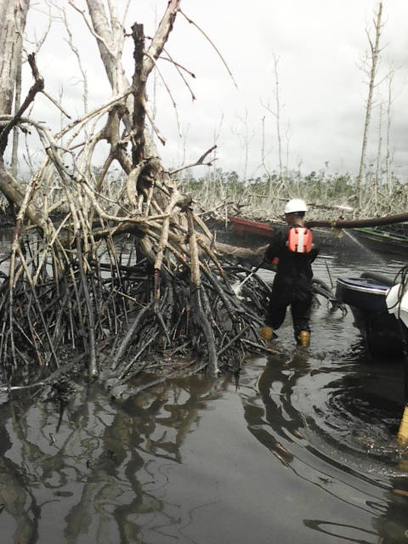
Figure 3 FLUSHING OF DEAD MANGROVE
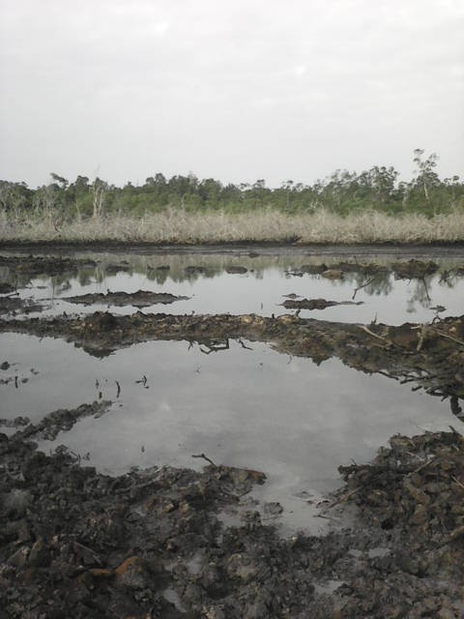
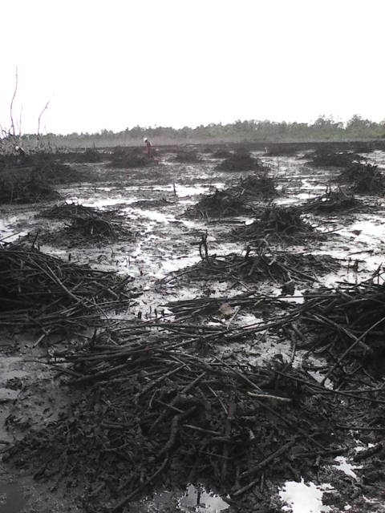

Figure 4 FRONT VIEW OF THE CLEAN UP SITE.
Figure 5 SIDE VIEW OF CLEAN UP SITE.
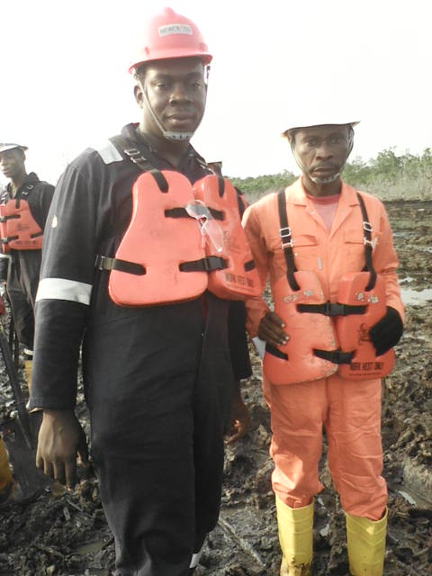
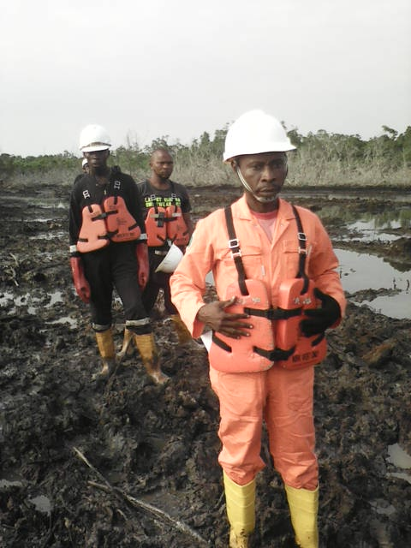
Figure 6 EVIDENCE OF STORAGE TANK.
Figure 8 NOSDRA STAFF AND NEWCROSS REP.

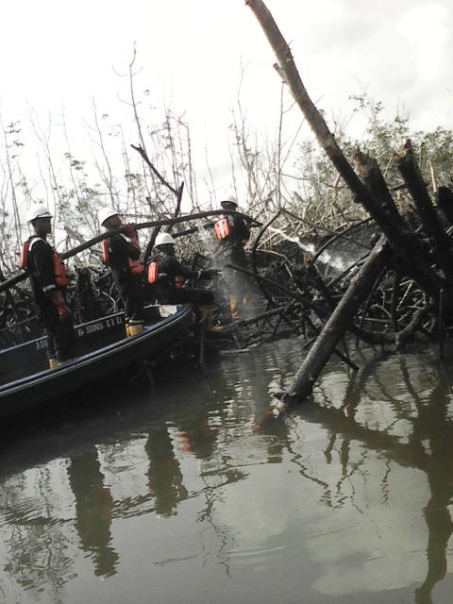
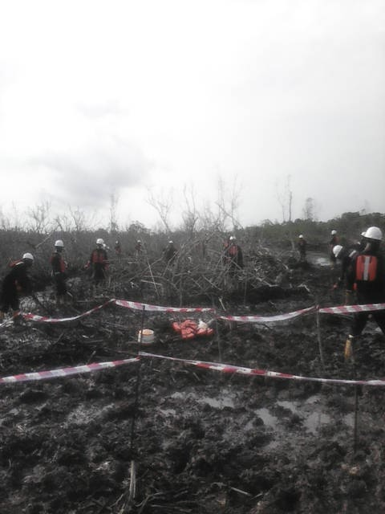
Figure 7 RAKEING AND AGITATION ONGOING.
Figure 8 FINAL STAGE OF FLUSHING EXERCISE.
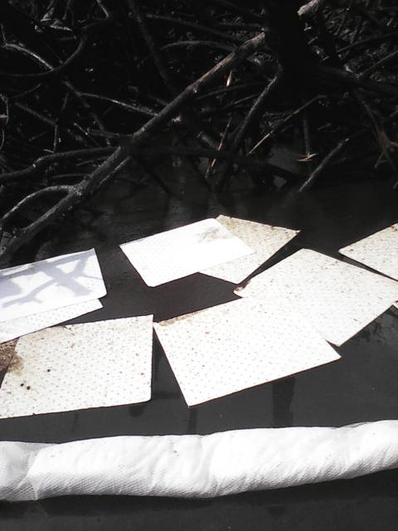
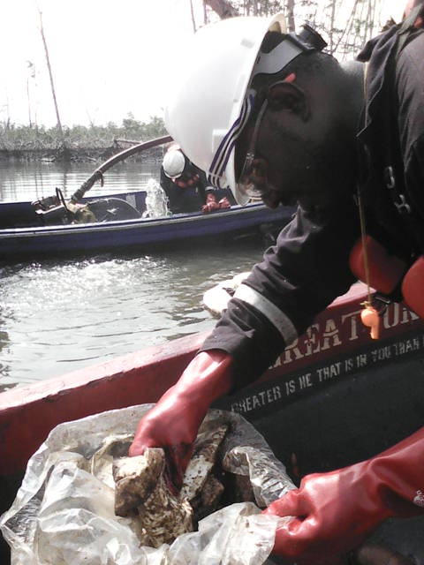
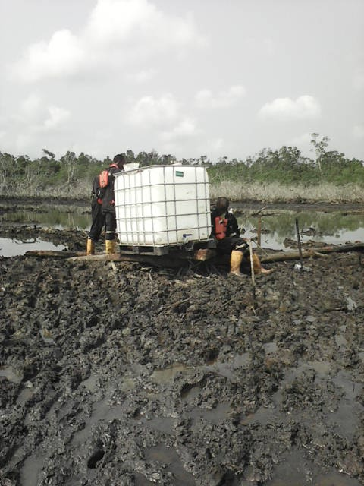

Figure 8 Mopping of dead crude on surface water.
Figure 8 BOOMS AND ABSOBENT PADS.
Figure 8
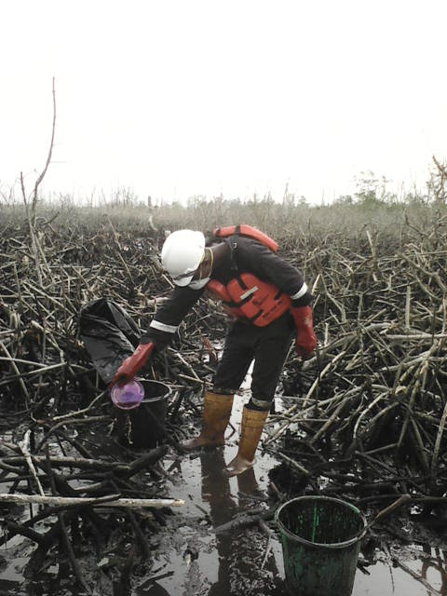
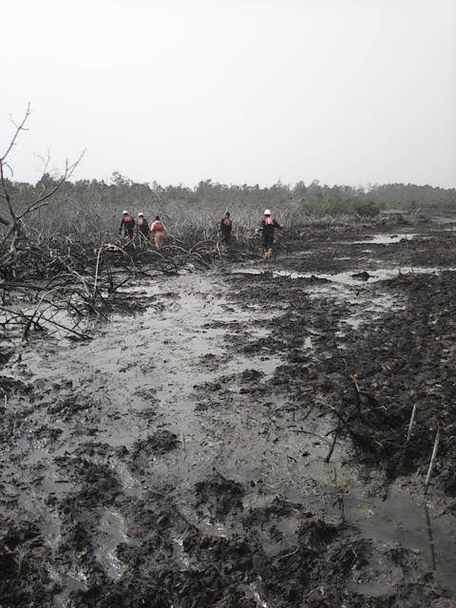

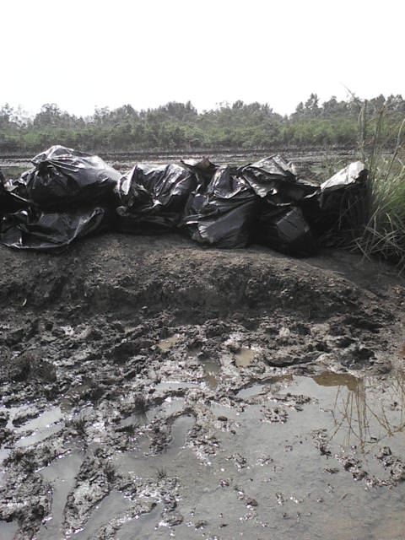
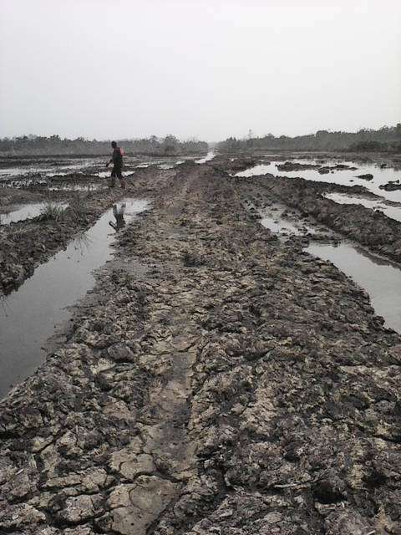
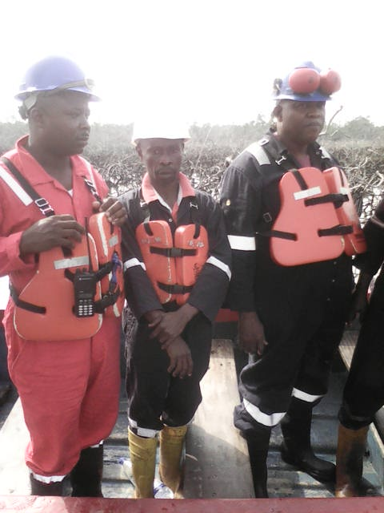
Figure 11 NOSDRA, N/CROSS MANAGER/ SUPERVSOR.
Figure 9 Gathering of oil debris ongoing.
Figure 10 Application of OSE 11 in progress.
Figure 12 BAGS CONTAINING WASTE .
Figure 13 CLEAN UP SITE RIGHT OF WAY.

